**3.2 Jenkins Set-up**

This section will guide you to:

* Download and set up the Jenkins app

This lab has two sub-sections, namely:

3.2.1 Downloading the Java Runtime Environment

3.2.2 Downloading and installing the Jenkins app

**Step 3.2.1:** Downloading the Java Runtime Environment

* Open the terminal.
* Run ***sudo apt update*** to update the package lists.
* Run ***sudo apt install openjdk-8-jdk*** to install the Java Runtime Environment.
* Run ***java -version*** to verify the installation. It will print the JDK version as shown below:

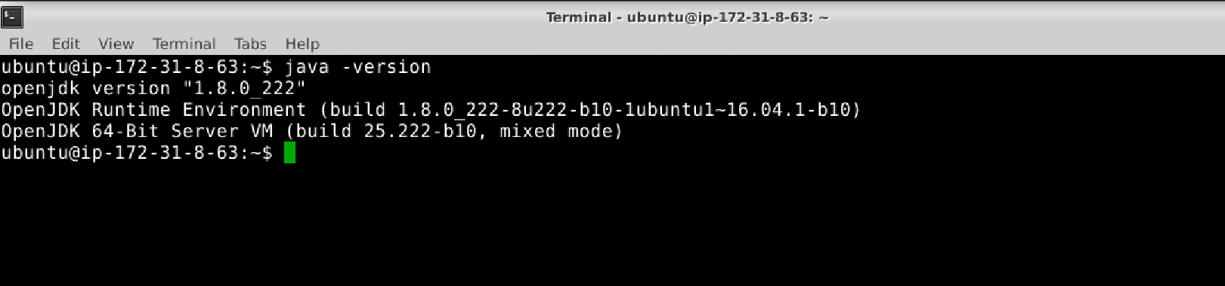

**Step 3.2.2:**  Downloading and installing the Jenkins app

* Open the terminal.
* Run ***wget -q -O - https://pkg.jenkins.io/debian/jenkins.io.key | sudo apt-key add -*** to install Jenkins.
* Run the command ***sudo sh -c 'echo deb http://pkg.jenkins.io/debian-stable binary/ > /etc/apt/sources.list.d/jenkins.list'.***
* Run ***sudo apt install jenkins*** to install Jenkins.
* Run ***systemctl status jenkins*** to check the status of the installation.
* Run ***sudo /etc/init.d/jenkins start*** to start Jenkins.
* Jenkins will now open up at port 8081 as shown below:

